**TITLE:** **E-commerce App**

**Problem Statement**: Build an artisanal e-commerce platform using IBM Cloud Foundry. Connect skilled artisans with a global audience. Showcase handmade products, from exquisite jewelry to artistic home decor. Implement secure shopping carts, smooth payment gateways, and an intuitive checkout process. Nurture creativity and support small businesses through an artisan's dream marketplace!

**Design Thinking:**

Platform Design: Design the platform layout with sections for product categories, individual product pages, shopping cart, checkout, and payment.

Product Showcase: Create a database to store product information such as images, descriptions, prices, and categories.

User Authentication: Implement user registration and authentication features to enable artisans and customers to access the platform.

Shopping Cart and Checkout: Design and develop the shopping cart functionality and a smooth checkout process.

Payment Integration: Integrate secure payment gateways to facilitate transactions.

User Experience: Focus on providing an intuitive and visually appealing user experience for both artisans and customers.

Step 1:create an e commece platform.

In this we are creating “ORANGE STORE”

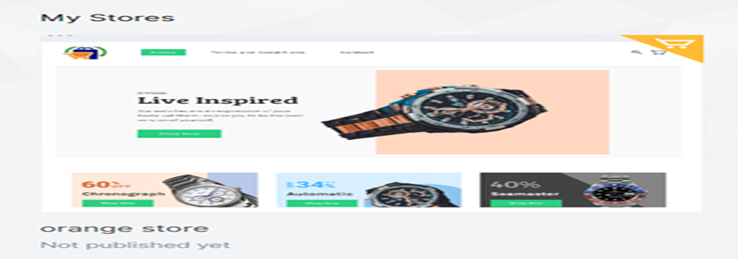

STEP 2:dash board for our app appears..

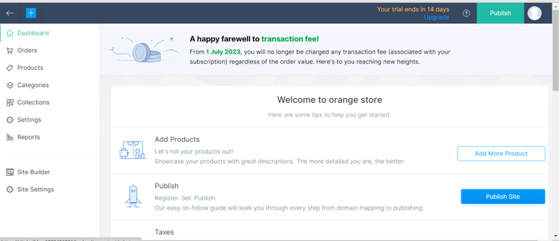

STEP3: Add product details…on selling price and retail price the details

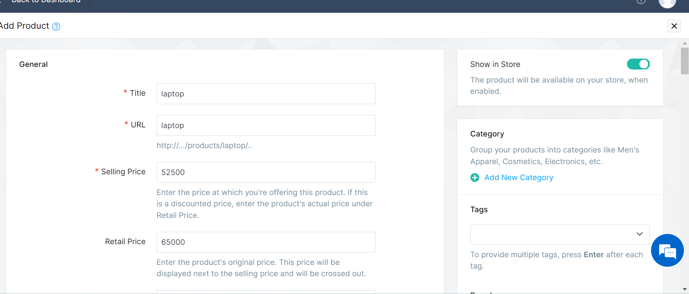

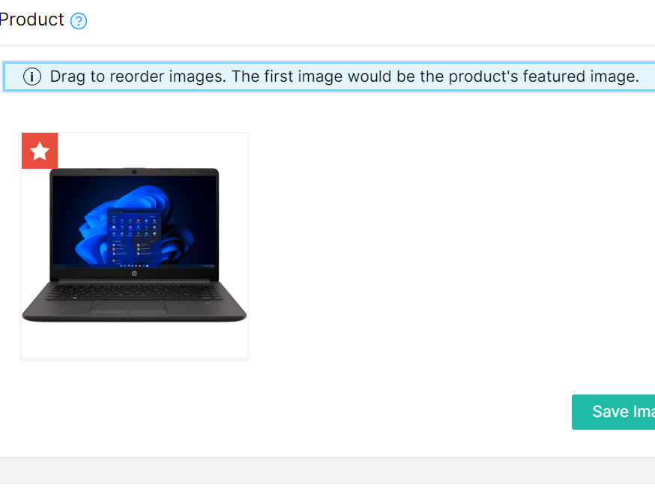

STEP4:go to products collection pg and check

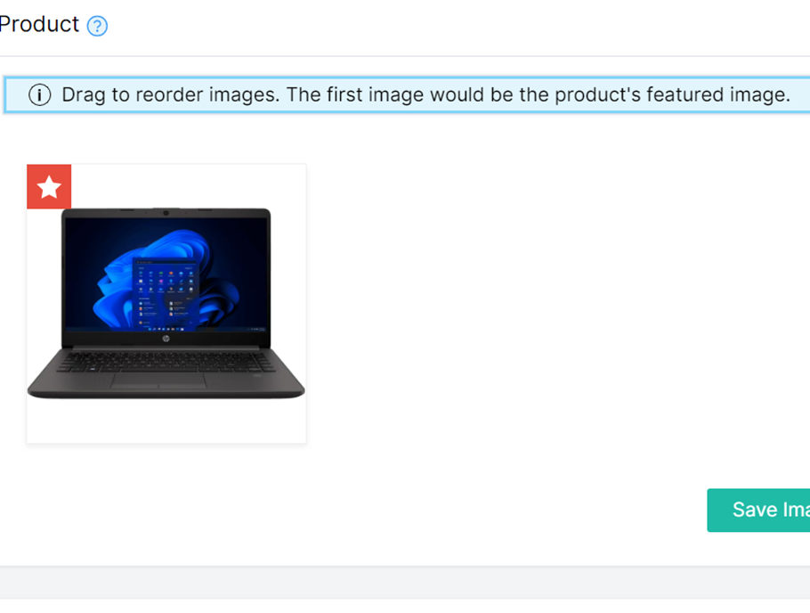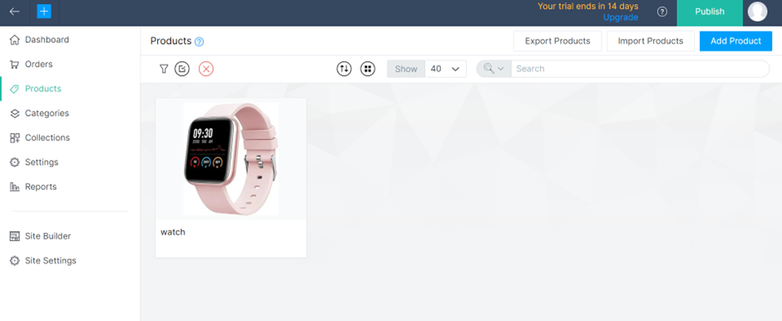

Step 5:we can publish by clicking publish…we can sell our products.

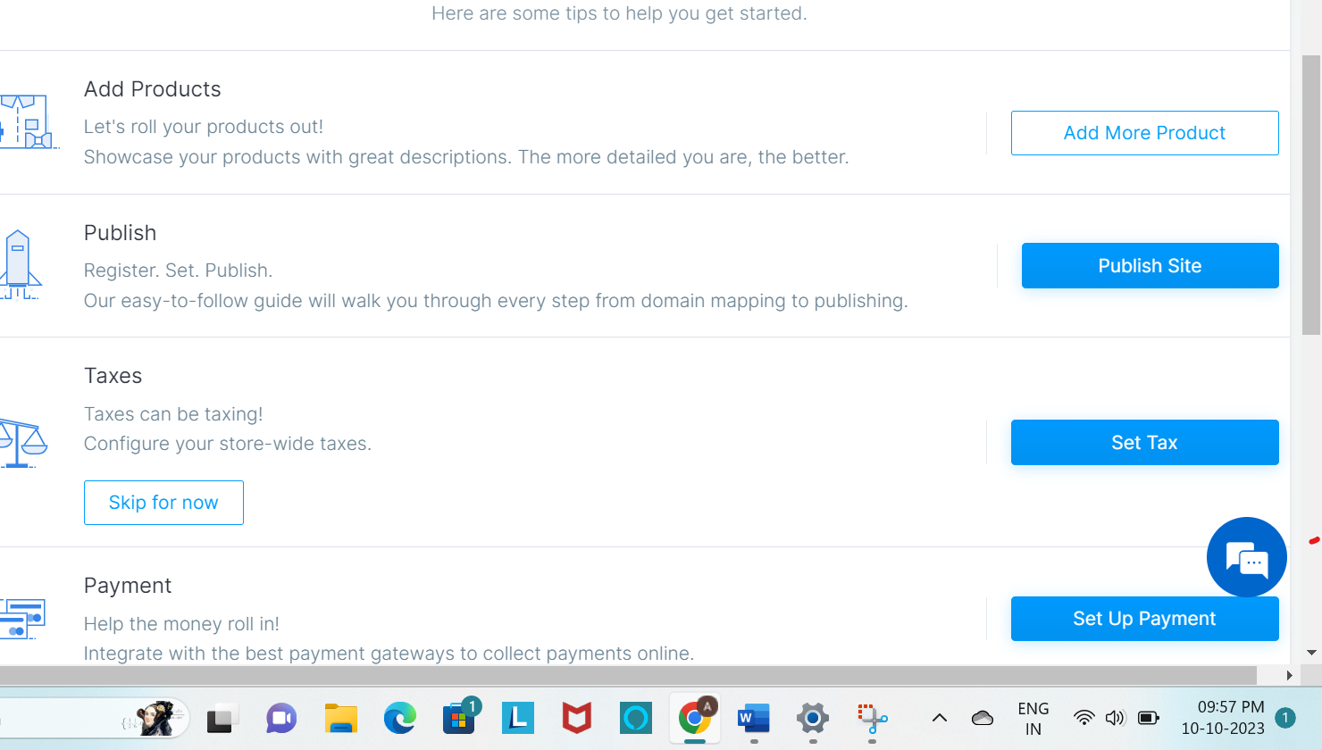bo

Step 6: our store is ready ..

CONCLUSION:

The business to consumer aspect of electronic commerce (e-commerce) is the most visible business use of the Word Wide Web. The primary goal of an e-commerce site is to sell goods and services online.